NETWORKING 8

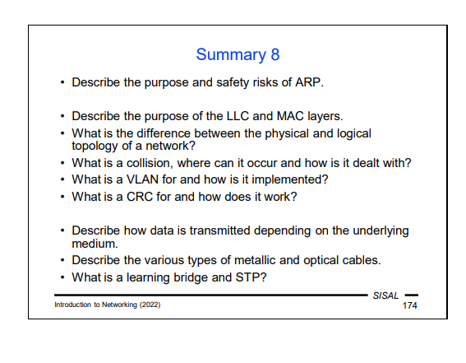

A problem with ARP is its lack of security, i.e. that the broadcast query will reach everyone, so any node of the network can answer us. Worse, a potential attacker doesn't even have to wait for our request. An unsolicited ARP message (a so-called Gratuitous ARP) is possible, which is actually an answer without a prior query. Such messages are used e.g. for cluster solutions –important machines in the network can run redundantly, both sharing the same IP address. An active machine of the pair informs other machines on the network using gratuitous ARP about its MAC address as the one that they are currently expected to use for the shared IP address.
Some increase in security in certain types of networks can be achieved by denying certain important nodes (servers, routers) from using the ARP protocol and fixing their ARP cache content by a configuration.
In a complex LAN, network management can choose not to disclose details about subnets to all stations on the network, leaving the correct routing purely up to the routers. Let's imagine the simplified situation in the picture above: there are two subnets in the network, but the stations are not told this information and are sent a network mask that corresponds to the entire network. If host A wants to communicate with host B, according to the network mask, it believes they're on the same network, so it sends an ARP query. But as we know, a broadcast query only spreads across a data link segment, and therefore over the subnet, where computer A is connected, so it never reaches host B. For the entire network to work, we need to run an ARP proxy on the router that splits the network. The router with an ARP proxy intercepts the ARP query and, recognizing that the client would never receive a response, it sends a reply instead of the target host, returning the router’s MAC address as the query response. The client will save this assignment to its ARP cache and use the router’s MAC address for further communication with host B.
It may seem strange, but if we think about it more carefully, the client will actually behave in exactly the same way as if it had the right information about the netmask and knew about the router –if it did, it would also send packets for host B with the MAC address of the nearest router!
A user on the station can tell the difference by looking at the ARP cache. He will find multiple IP addresses with the same MAC address. If we have an ARP proxy in the network, this situation is expected. But if not, multiple occurrences of the same MAC address in the ARP cache may signal an attempt to attack our ARP cache using fake ARP messages.
The station does not have access to frames with a different VLANID that are transmitted over the network. This will logically separate traffic across different virtual networks. However, there are usually nodes in a network that need to have access to frames from all virtual networks (e.g. a central router). For them, the mount point is then configured as a so-called trunk, in which case the switch does not do any operations with the frame, and VLAN tag handling is left at the end node.
A slight complication is that each frame is lengthened by adding a tag, so that all the network devices that tagged frames pass through must be able to work with frames
longer than the maximum allowed. Another option is to inform all stations on the network that the maximum allowable frame is 4 bytes shorter than the standard.

We have already encountered fields containing a content check several times when describing various PDUs. Examples include the IP header checksum, or the Frame Check Sequence in frame footer. Most of these control mechanisms use the CRC (Cyclic Redundancy Check) hashing function. This function is based on a division of polynomials, which is quite interesting, because it may seem like such a calculation would be quite complex, and yet it can be done very easily with hardware.
The basic idea is that we convert a sequence of bits into a polynomial with binary coefficients that correspond to individual bits and an order that corresponds to the number of bits. This polynomial is then divided by the so-called characteristic polynomial. This polynomial’s degree must be equal to the number of bits in a control field. The polynomial that comes out as the remainder after the division is converted again into a sequence of bits, and this gives us the result of a fixed-size function corresponding to the order of the characteristic polynomial.
Despite its simple implementation, the method has surprisingly great power. It can detect all errors with an odd number of bits, all errors shorter than the number of bits of the control field, and even for errors of a different range it has a relatively high success rate.

